Prospectus Supplement No. 4 | Filed Pursuant to 424(b)(3)
(to Prospectus dated June 28, 2016) | Registration No. 333-212095

1,081,082 Shares
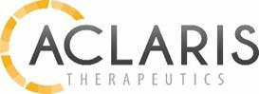

Common Stock

This prospectus supplement updates and should be read in conjunction with the prospectus dated June 28, 2016 (the “Prospectus”) relating to the resale or other disposition, from time to time, by the selling stockholders identified in the Prospectus under the caption “Selling Stockholders,” of up to 1,081,082 shares of our common stock, par value $0.00001 per share. We are not selling any shares of our common stock under the Prospectus and will not receive any proceeds from the sale or other disposition of shares by the selling stockholders. The selling stockholders will bear all commissions and discounts, if any, attributable to the sale or other disposition of the shares. We will bear all costs, expenses and fees in connection with the registration of the shares. To the extent that there is any conflict between the information contained herein and the information contained in the Prospectus, the information contained herein supersedes and replaces such information.

Current Report

This prospectus supplement incorporates into our Prospectus the information contained in our attached current report on Form 8-K that we filed with the Securities and Exchange Commission on September 13, 2016 (the “Form 8-K”). The Form 8-K, as filed, is set forth below.

The information contained in this Prospectus Supplement No. 4 supplements and supersedes, in relevant part, the information contained in the Prospectus, as amended and supplemented to date. This Prospectus Supplement No. 4 is incorporated by reference into, and should be read in conjunction with, the Prospectus, as amended and supplemented to date, and is not complete without, and may not be delivered or utilized except in connection with, the Prospectus, as amended and supplemented to date.

The Prospectus, together with Prospectus Supplement No. 1, Prospectus Supplement No. 2, Prospectus Supplement No. 3 and this Prospectus Supplement No. 4 constitutes the prospectus required to be delivered by Section 5(b) of the Securities Act of 1933, as amended, with respect to offers and sales of the securities as set forth in the Prospectus, as amended and supplemented. All references in the Prospectus to “this prospectus” are amended to read “this prospectus (as supplemented and amended to date).”

Our common stock is traded on the NASDAQ Global Select Market under the symbol “ACRS.” The last reported sale price of our common stock on September 12, 2016 was $23.24 per share. You are urged to obtain current market quotations for the common stock.

We are an “emerging growth company” as defined by the Jumpstart Our Business Startups Act of 2012 and, as such, we have elected to comply with certain reduced public company reporting requirements for this prospectus and future filings. Please see “Prospectus Summary—Implications of Being an Emerging Growth Company.”

Investing in our common stock is highly speculative and involves a significant degree of risk. See “Risk Factors” beginning on page 5 of the Prospectus and the Risk Factors identified in our Annual Report for the year ended December 31, 2015 and in our Quarterly Report for the quarter ended June 30, 2016 for a discussion of information that should be considered before making a decision to purchase our common stock.

Neither the Securities and Exchange Commission nor any state securities commission has approved or disapproved of these securities or determined if this prospectus is truthful or complete. Any representation to the contrary is a criminal offense.

The date of this prospectus supplement is September 13, 2016.

UNITED STATES
SECURITIES AND EXCHANGE COMMISSION
Washington, D.C. 20549

FORM 8-K

CURRENT REPORT

Pursuant to Section 13 or 15(d) of the
Securities Exchange Act of 1934

Date of Report (Date of earliest event reported): September 13, 2016

ACLARIS THERAPEUTICS, INC.
(Exact name of registrant as specified in its charter)

Delaware
(State or other jurisdiction of incorporation)

001-37581 | 46-0571712
(Commission File No.) | (IRS Employer Identification No.)
 | 101 Lindenwood Drive, Suite 400
 | Malvern, PA 19355

(Address of principal executive offices and zip code)

Registrant’s telephone number, including area code: (484) 324-7933

(Former name or former address, if changed since last report.)

Check the appropriate box below if the Form 8-K filing is intended to simultaneously satisfy the filing obligation of the registrant under any of the following provisions:

- Written communications pursuant to Rule 425 under the Securities Act (17 CFR 230.425)

- Soliciting material pursuant to Rule 14a-12 under the Exchange Act (17 CFR 240.14a-12)

- Pre-commencement communications pursuant to Rule 14d-2(b) under the Exchange Act (17 CFR 240.14d-2(b))

- Pre-commencement communications pursuant to Rule 13e-4(c) under the Exchange Act (17 CFR 240.13e-4(c))

Item 8.01 Other Events.

On September 13 and 14, 2016, members of management of Aclaris Therapeutics, Inc., or the Company, will hold meetings to review, among other things, the Company’s product candidate pipeline and clinical development. In addition, on September 14, 2016, Neal Walker, the President and Chief Executive Officer of the Company, will present at the Morgan Stanley 2016 Global Healthcare Conference on, among other things, the Company’s product candidate pipeline and clinical development. A copy of the presentation that will accompany the meetings and which is being presented at the Morgan Stanley conference is available on the Company’s website at www.aclaristx.com, and is filed as Exhibit 99.1 to this Current Report on Form 8-K, the contents of which are incorporated herein by reference. A second presentation regarding the Company’s wart disease program is also available on the Company’s website at www.aclaristx.com, and is filed as Exhibit 99.2 to this Current Report on Form 8-K, the contents of which are incorporated herein by reference. The information contained in this Current Report on Form 8-K speaks only as the date hereof. While the Company may elect to update the information in this Current Report on Form 8-K in the future, the Company disclaims any obligation to do so except to the extent required by applicable law.

Item 9.01 Financial Statements and Exhibits.

- Exhibits

Exhibit No. Description
99.1 Aclaris Therapeutics Corporate Overview Presentation.
99.2 Aclaris Therapeutics Wart Disease Presentation.

SIGNATURES

Pursuant to the requirements of the Securities Exchange Act of 1934, the Registrant has duly caused this report to be signed on its behalf by the undersigned hereunto duly authorized.

Aclaris Therapeutics, Inc.

Date: September 13, 2016
By: /s/ Frank Ruffo
Frank Ruffo

Chief Financial Officer

Exhibit 99.1


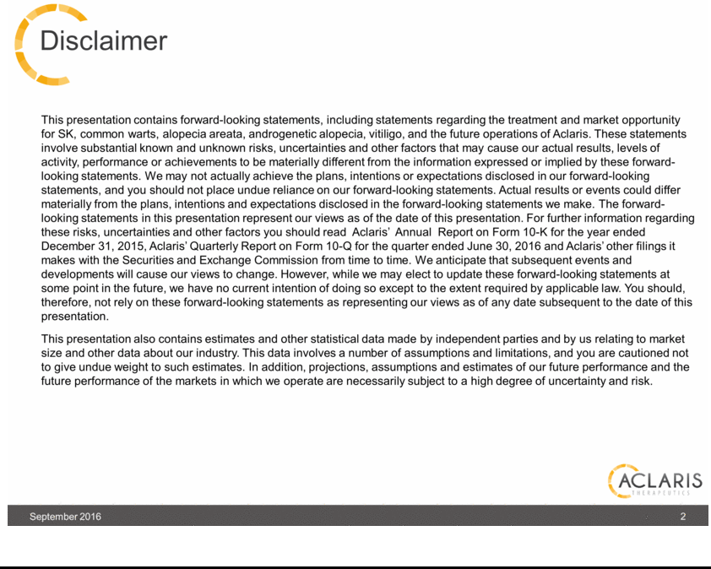

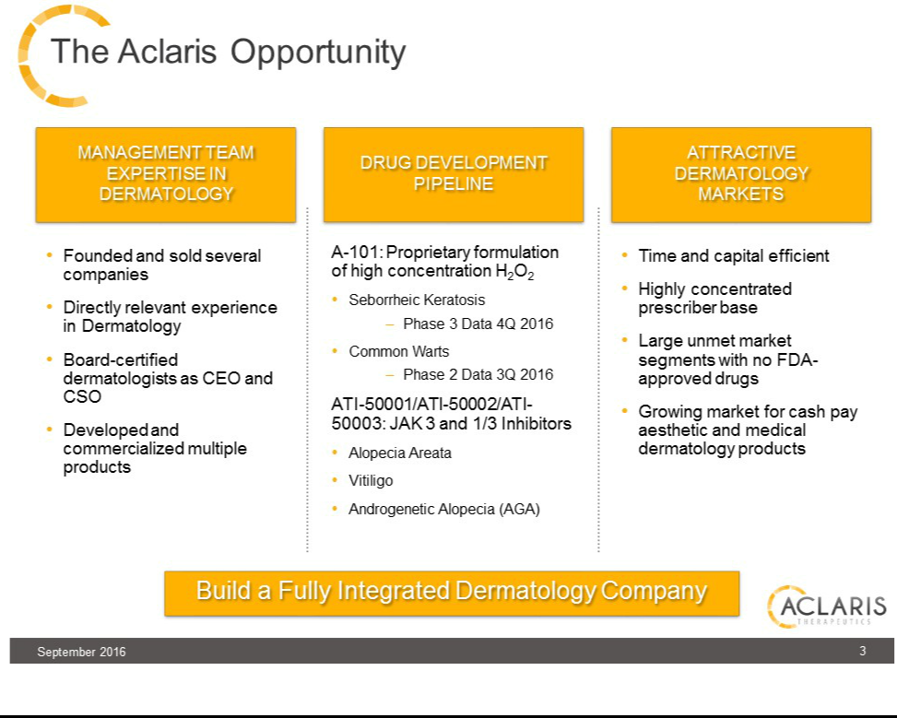

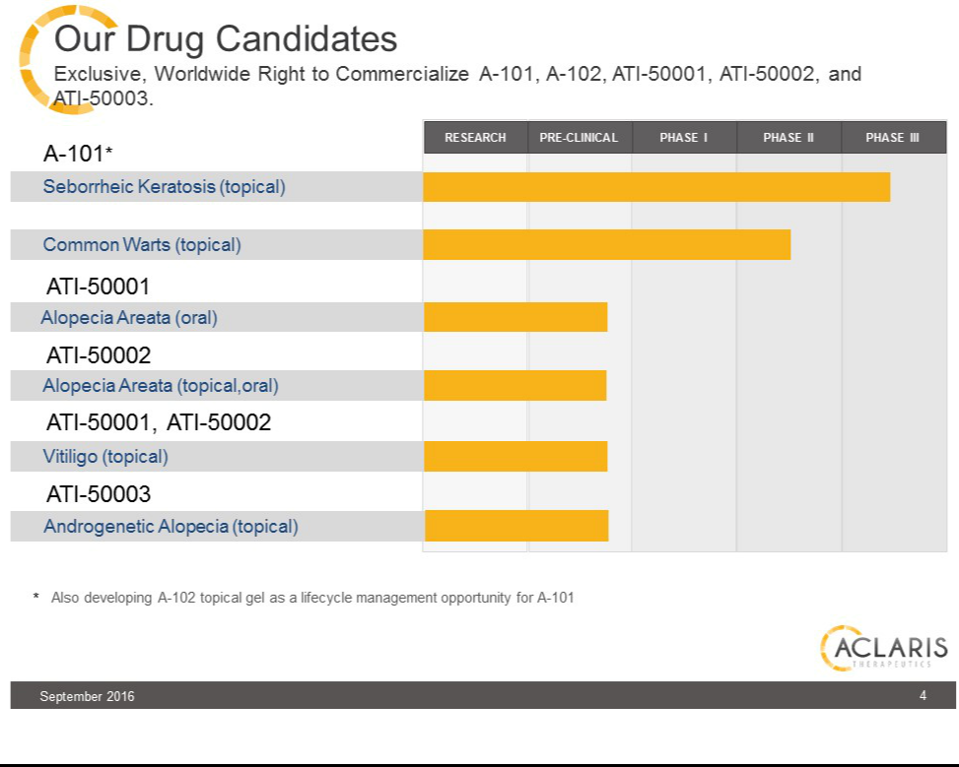

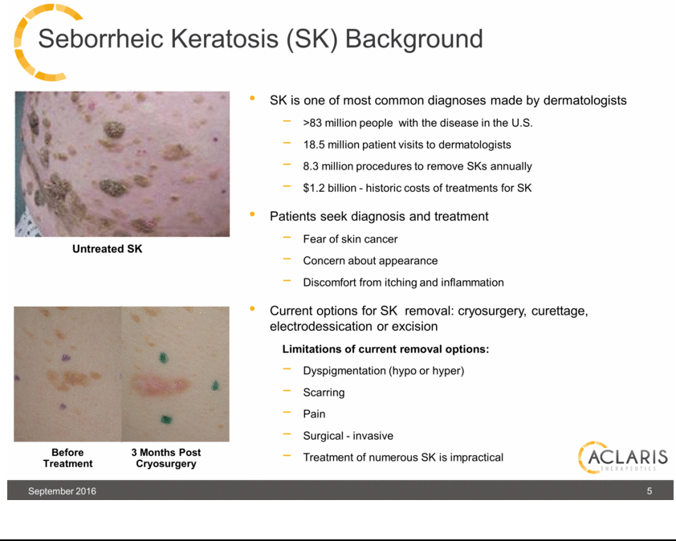

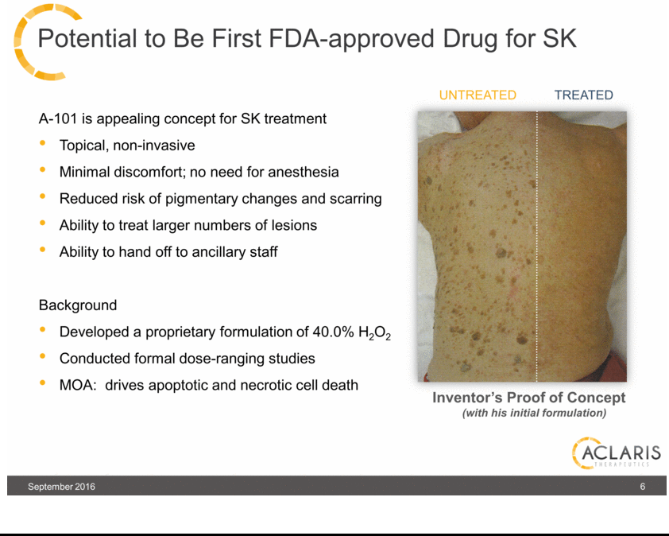

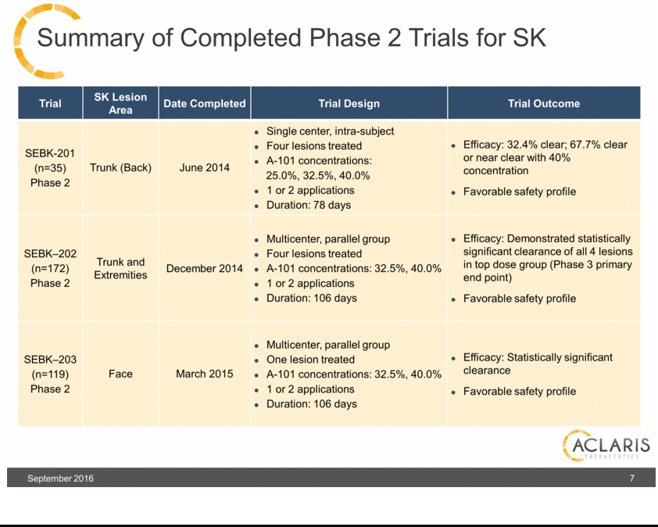

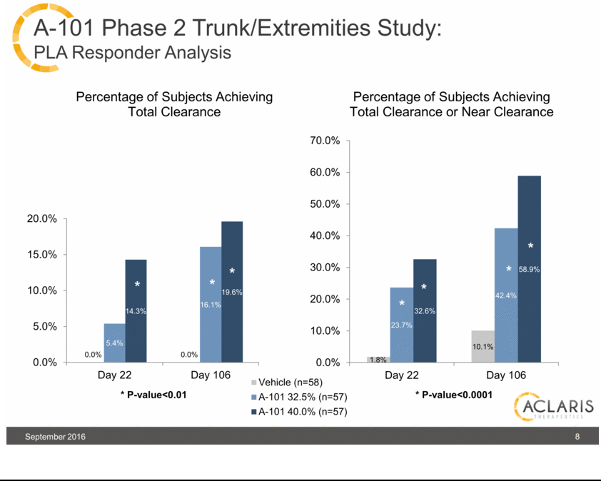

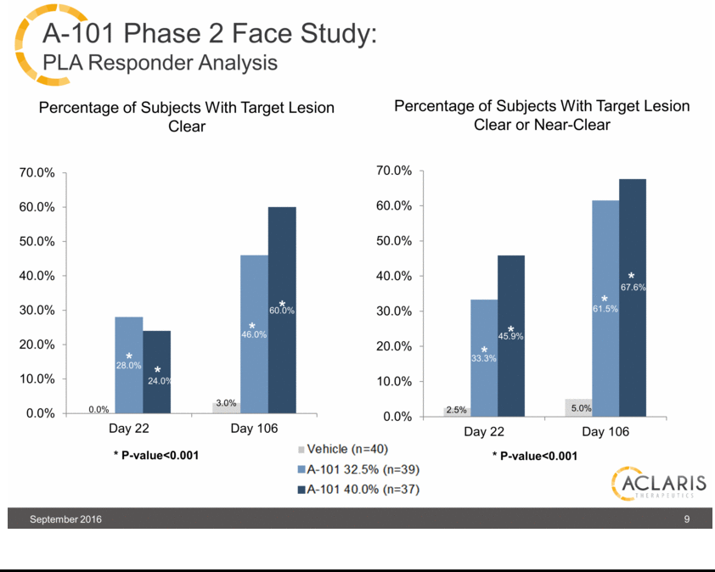

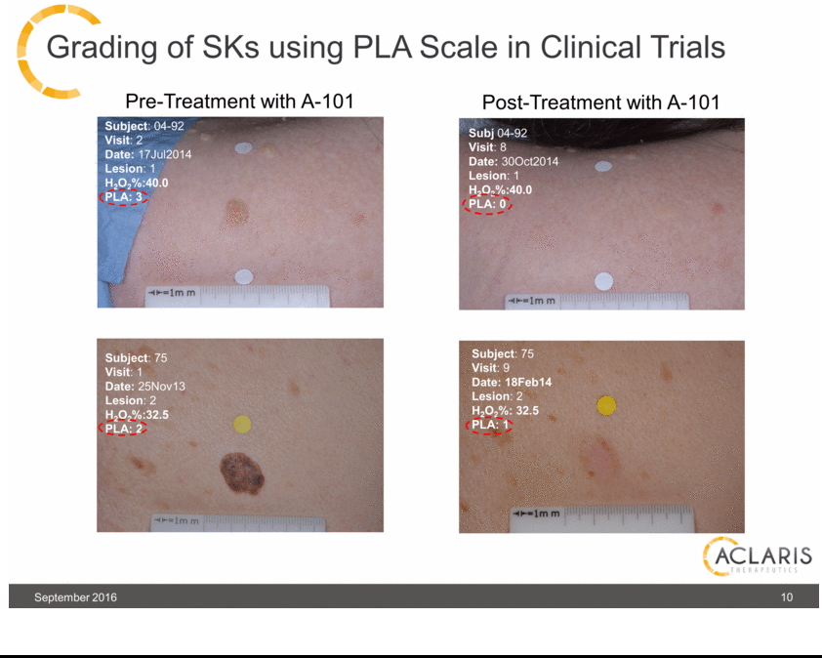

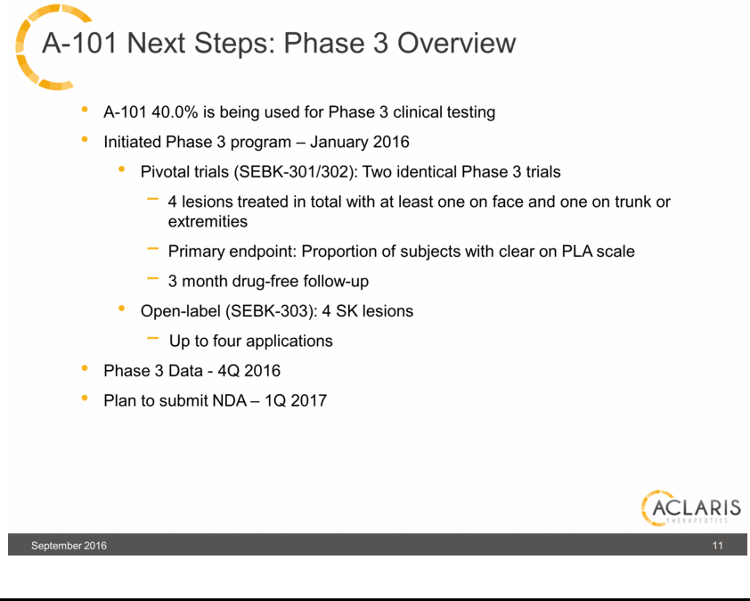

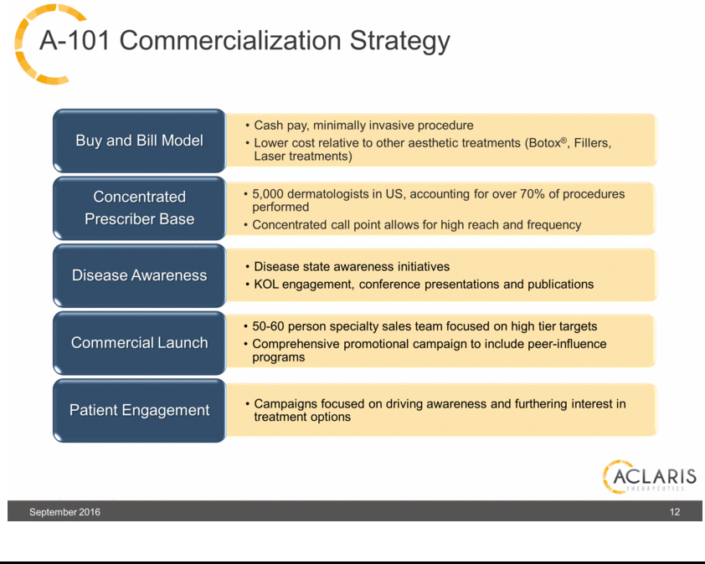

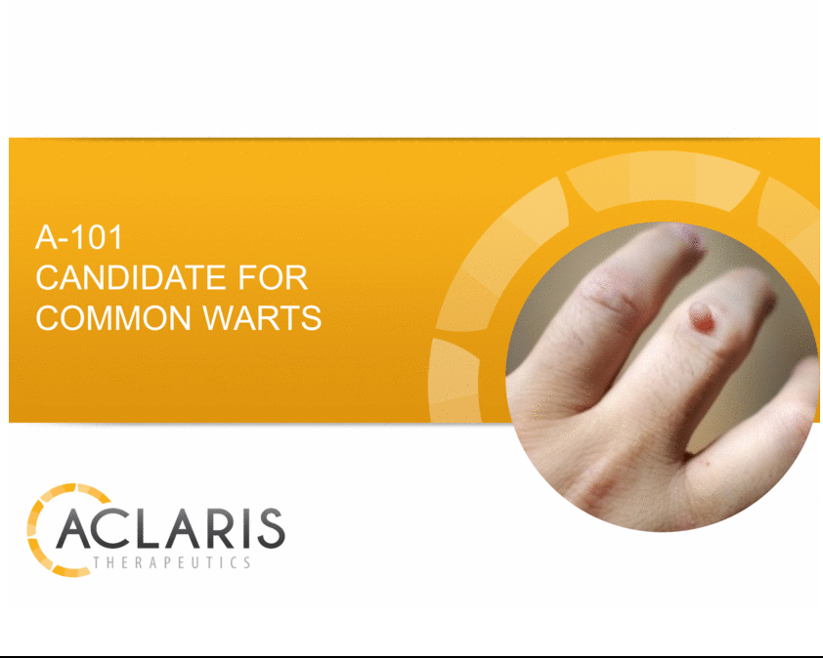

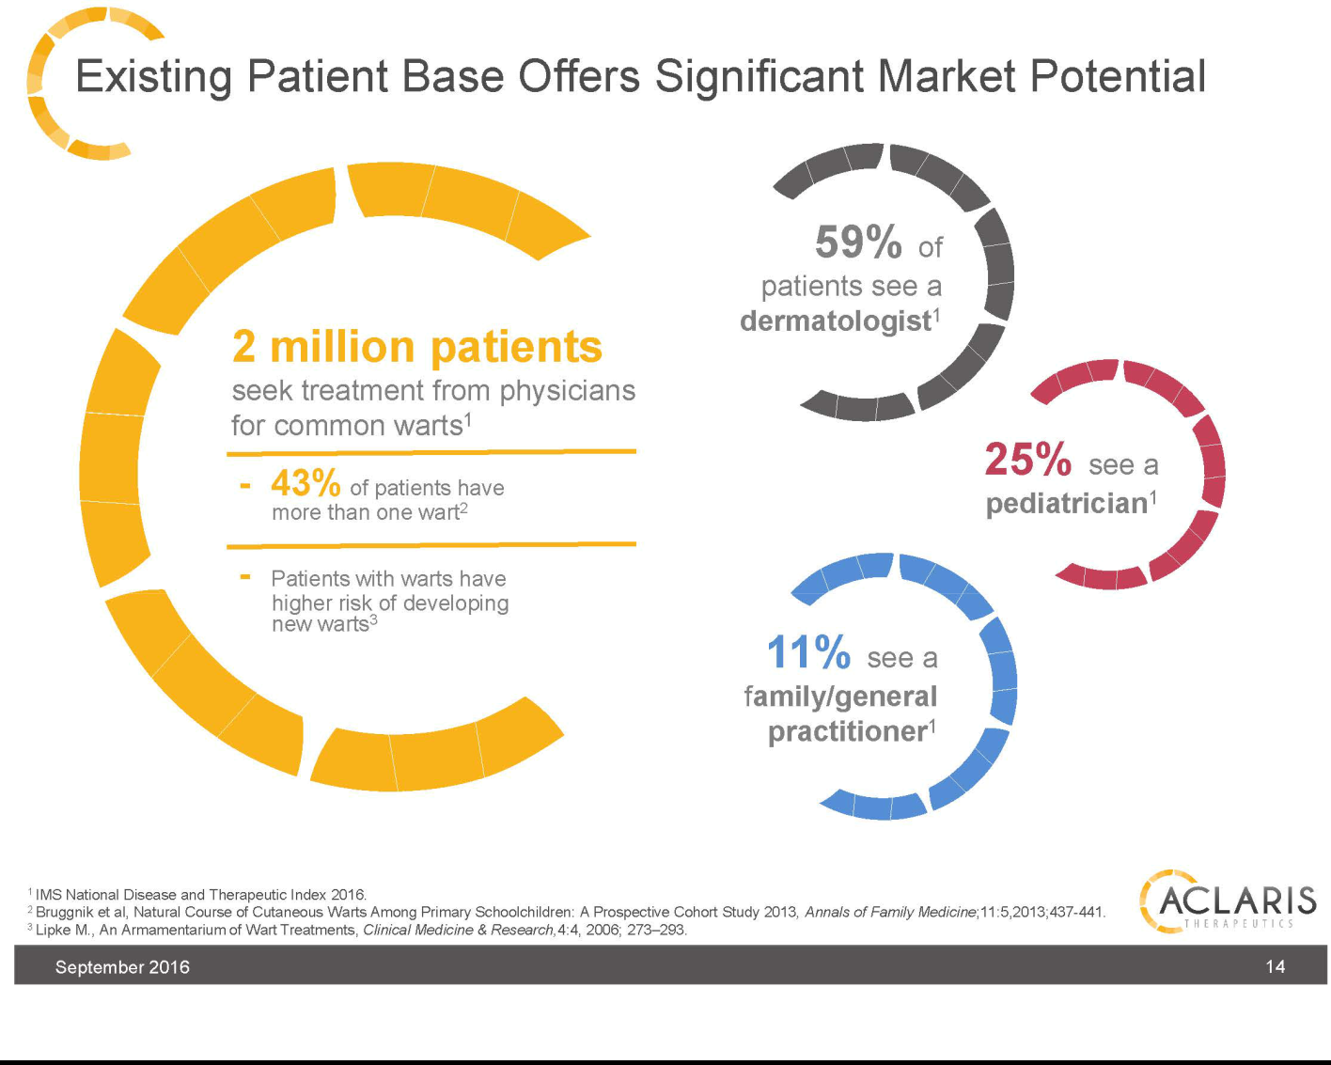

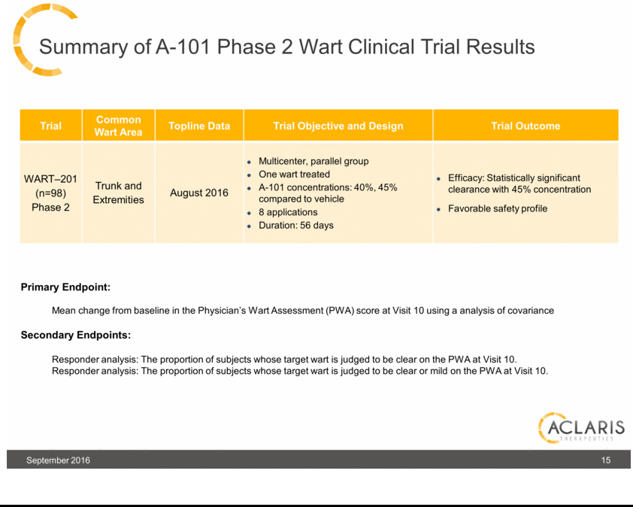

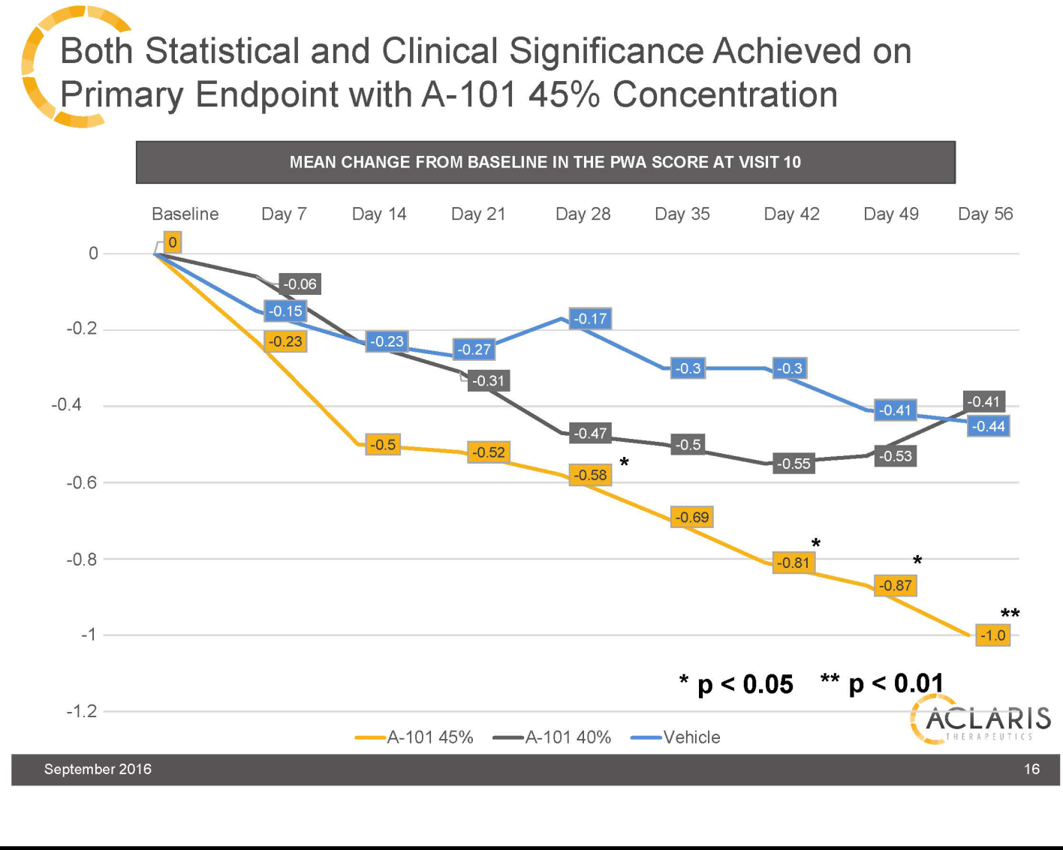

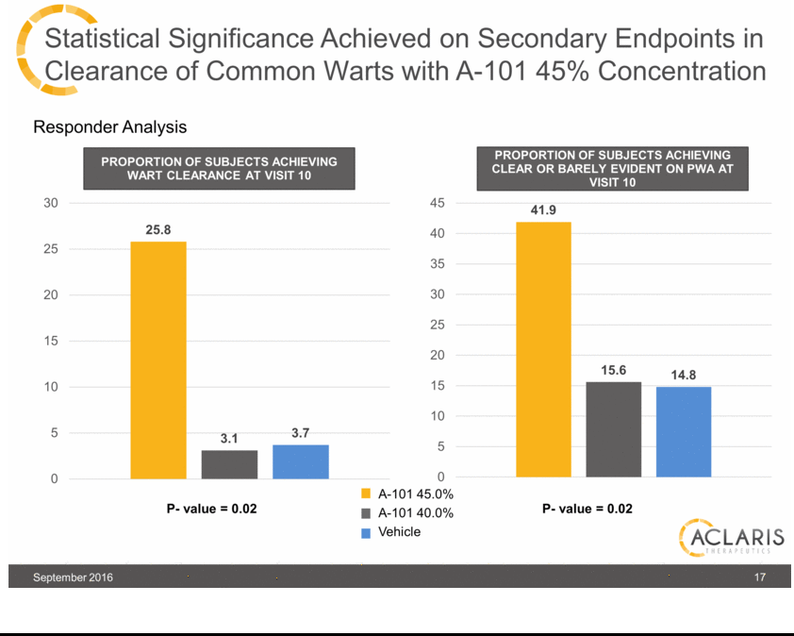

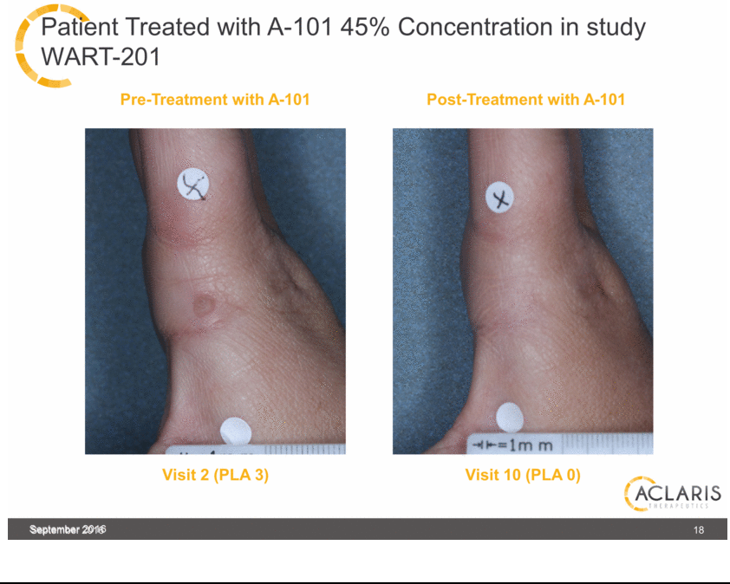

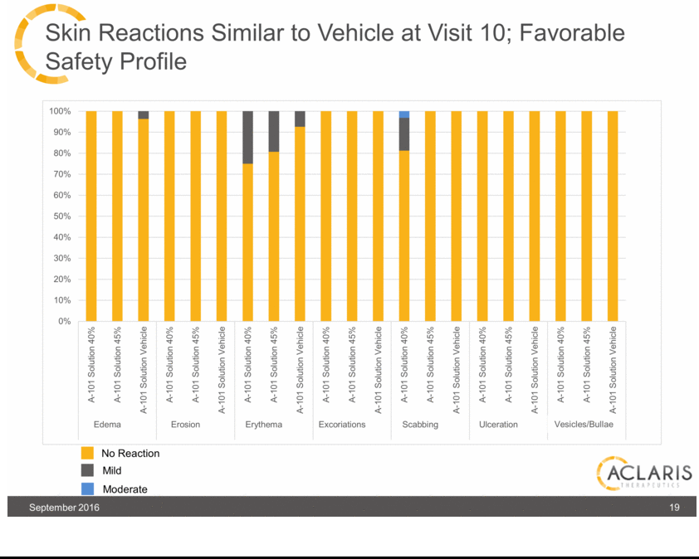

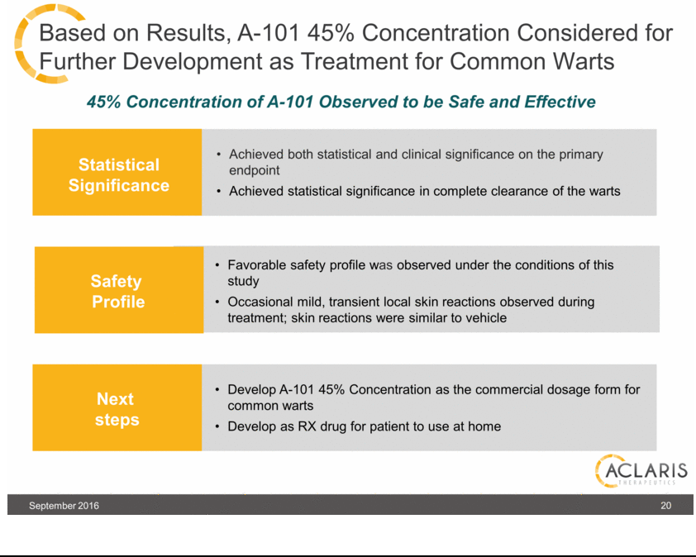

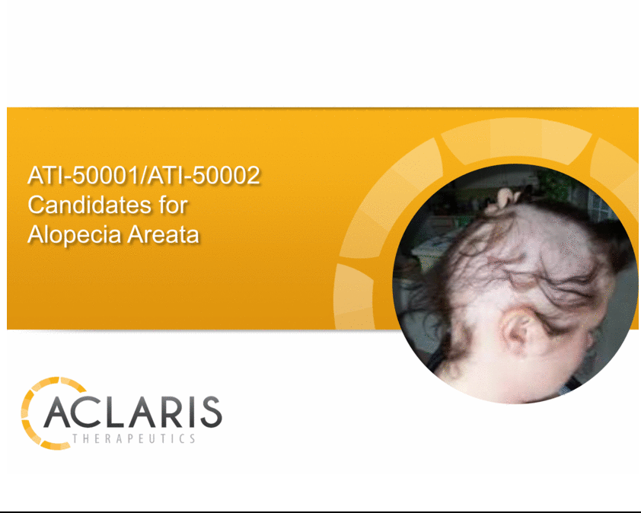

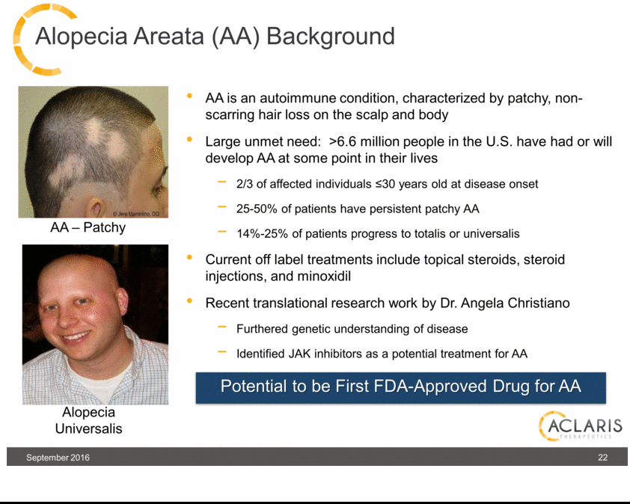

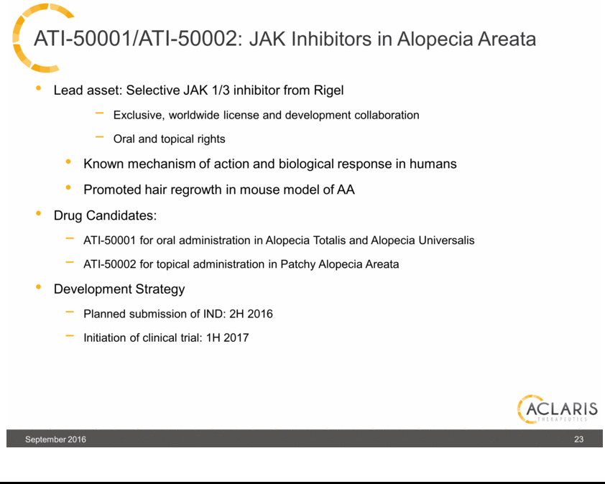

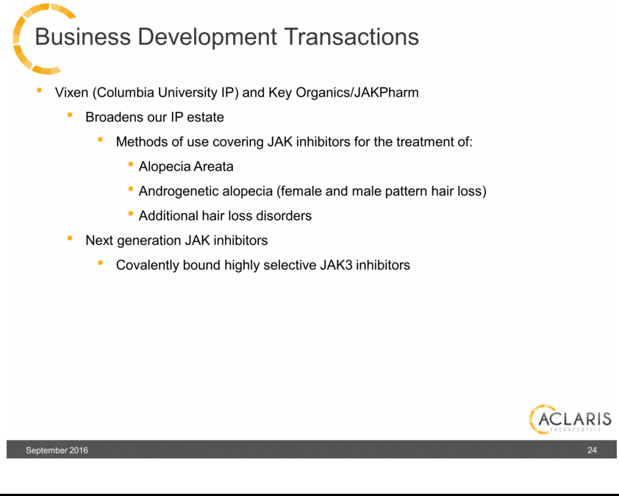

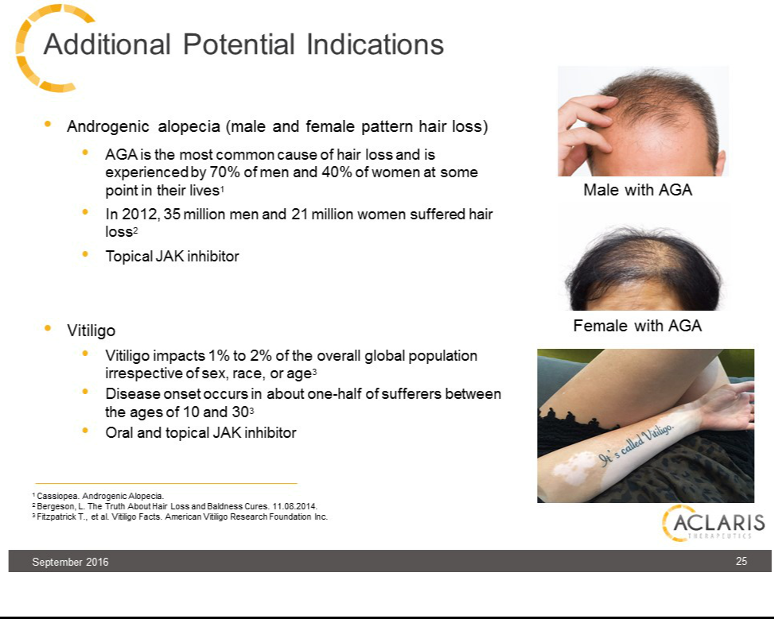

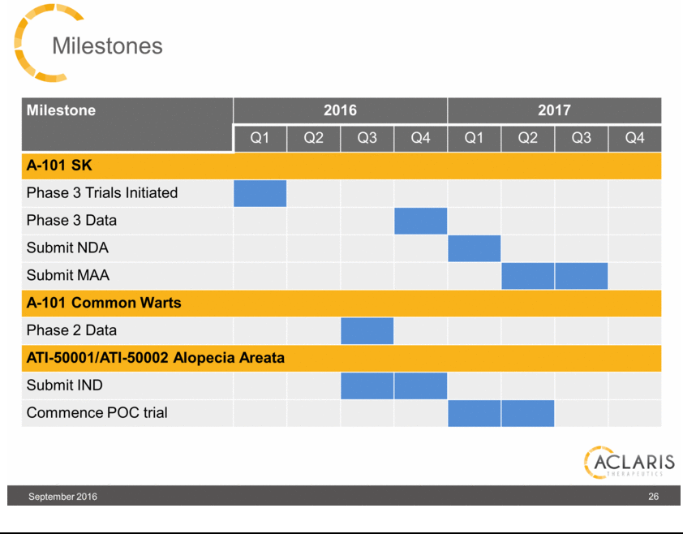



Exhibit 99.2






